Christmas Store
Volunteer Training Packet
2018

The Christmas Store is…

an opportunity for under-resourced families in our community to purchase new donated gifts at minimal prices so that they can share an affordable Christmas celebration with their children. Most families come from the Puente del Pueblo network and their partnership with Winfield township and District 33 & District 94 Social Workers.

If you would like more information about our Christmas Store, please visit our website at www.christmastore.org .

The Christmas Store partners with Local Churches in our community who host gift drives and provide volunteers in order to make the event happen. As gifts come in, they are sorted by ages, priced at 75%-80% off their retail value and then sold to families who have been invited and made appointments with Puente del Pueblo case managers.

The money that is collected by the Christmas store, goes back to providing resources, like
After School Programming, rental assistance, ESL tutoring and Spanish Literacy, to the families in the Puente del Pueblo Network.

Thank you very much for serving with us and making this annual Christmas Store happen!

A Couple of Reminders:

When you come for your assigned shift. Please do NOT park in the front parking lot. We like to keep those spots open for Shoppers. Parking for volunteers can be found on the East side of the building where volunteers will enter through the Volunteer Entrance, Door S2, facing the pond.

Volunteers will be reporting to the Lower level/basement (attached is a map of Community Fellowship church’s Lower and Upper levels). Please check-in at Room 112A with a Volunteer Coordinator 15-20 minutes before your shift. There is a place to hang your coats and there will be cookies, coffee and light refreshments for you to enjoy before your shift, if you decide to arrive early. Lunch is ONLY be provided for volunteers who are staying all day and working both shifts.

The Christmas Store will be operating on the Upper level of the building. A map of the church is attached so you can become more familiarized with the space.

If you are serving in the AM shift, please report to Community Fellowship Church at 8:30AM,
your shift will end at 12:30 PM.

If you are serving in the PM shift, please report to Community Fellowship Church at 12:30PM, your shift will end at 4:30PM.

Please remember to wear your Christmas Store t-shirt the day of the Store.

We are so excited to share this serving experience with you!

Merry Christmas!

The Christmas Store Committee
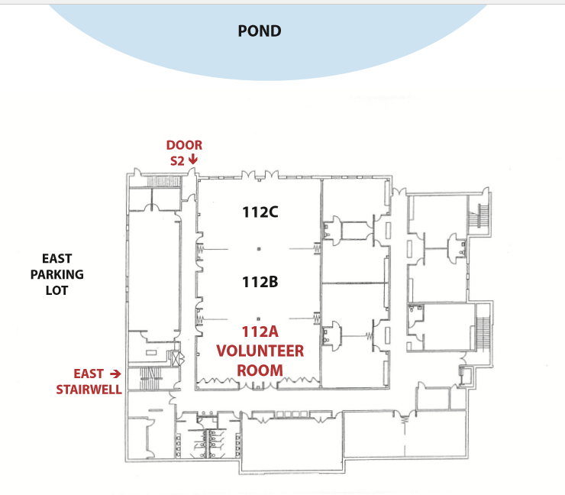
Lower Level -Community Fellowship Map
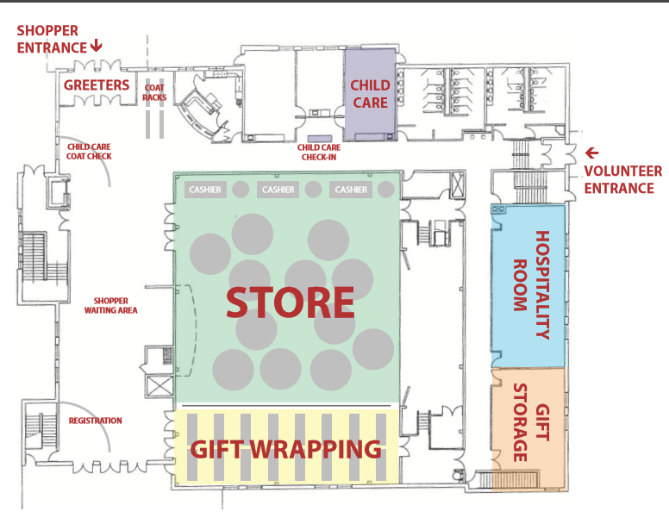
Upper Level -Community Fellowship Map

Christmas Store

Set Up Team Responsibilities Detail

Summary:
- Thursday night setting up the Christmas Store, to be ready for decorating and gifts on Friday.
- These tasks are directed by one of the Volunteer Coordinators
- Ideal for High School and Adults. Standing, moving tables, walking.

Responsibilities:
- This shift is from 6:00 pm – 8:00 pm Thursday night.
- Meet in Community Fellowship’s multi-purpose gym/Sanctuary on the Upper level
- This job involves rolling out and carrying tables into the Christmas Store area, setting them up, and arranging them in clusters for the Store, in a line for Cashiers, and in rows for Gift Wrapping
- Move the coat racks into the Reception/Greeting area.
- Assist the Volunteer Coordinator with placing signs all over the building, which will direct Volunteers and Shoppers to various areas.
- After these tasks are completed, feel free to come downstairs in Room 112ABC to help Sort and Price the gifts!
- Thank you for volunteering for the Christmas Store and HAVE FUN!!

Christmas Store

Christmas Store Pricing & Sorting Volunteers Responsibilities Detail

Summary:
- Thursday night before the store; Lower level, then moving to the Upper level
- This job involves sorting and pricing all the gifts for the store at Community Fellowship church.
- Pizza and pop are provided
- Standing, walking, carrying, stairs or elevator.
- Ideal for Families with Young Children, High School and College Students to get involved!

Responsibilities:
- This shift is from 6:00 pm – 8:00 pm Thursday night.
- Help move gifts from Storage into Room 112ABC for sorting and pricing.
- Please make sure that gifts stay in their correct categories by gender and age. They will generally be sorted ahead of time in the Storage room.
- Using provided price tags, price the gifts at 25% of the retail price.
In order to determine the retail price, you can either use the Amazon gift list or a Bar Code Scanner app on your cell phone. (Please note that some cell phones get better connectivity in the lower level of CF than others).
- Once the gifts are priced, they need to be counted, again by gender and age.
- Gifts are then placed into large plastic garbage bags to be transported to the Upper level of the church.
The plastic bag should have the number of gifts inside the bag and the gender on a label on the outside of the bag. Please make sure to count gifts as you put them in the bag.
- Help move the gifts to the Upper Level Gift Storage/“Green” Room.
- Thank you for volunteering to help with the Christmas Store, and HAVE FUN!!

Christmas Store

Store Decorating Responsibilities Detail

Summary:
- Assisting the Decoration Coordinator from Wheaton Bible Church in decorating Community Fellowship’s multi-purpose gym/Sanctuary (the Christmas Store shopping area), and the Shopper Hospitality Room for the day of the Christmas Store.
- This position requires mostly being able to take direction.
- Ideal for High School, College Students, Adults. Standing, Walking.

Responsibilities:
- Friday morning from 9:00 am – 12:00 pm
- Meet in Community Fellowship Church’s multi- purpose gym/Sanctuary
- All decorations are provided and our wonderful Christmas Store Decorator, Laura J., from Wheaton Bible Church, directs this task each year.
- You will assist with putting up and decorating artificial Christmas trees, hanging garland, putting tablecloths on tables, etc.
- You may be asked to handle various other simple tasks.
- Thank you for volunteering for the Christmas Store and HAVE FUN!!

Christmas Store

Child Care Responsibilities Detail

Summary:
- Provide care for the children of Shoppers, while they shop and spend time in the Hospitality Room
- You must be vetted at your home church to serve
- High School, College Students and Adults only.
- Must be older than 14 years old to serve in this area. No exceptions.
- Child care is for children of Shoppers only; we do not have the resources to provide care for volunteers’ children

Responsibilities:
- Arrive 15-20 minutes early and wear your Christmas Store t-shirt or we will provide one for you.
Arriving early is critical, since Shoppers often come early for their appointments!
- Please check in with the Volunteer Coordinator on the Lower level, before heading to the nursery.
- Community Fellowship's nursery is located on the Upper level.
- Since Community Fellowship’s nursery is set up for children under 2, if you can bring any coloring books or pages and crayons or games for the Shoppers’ older children, it would be very appreciated. This is not a necessary part of the position, but it will be helpful if there are older children in the nursery who are bored.
- That’s all – Thank you for volunteering for the Christmas Store and HAVE FUN!!

Christmas Store

Volunteer Hospitality Responsibilities Detail

Summary:
- Provide a warm and welcoming atmosphere for all volunteers for the Christmas Store.
- Circulate throughout the day to see if volunteers need anything.
- Make sure there is water and coffee available all day.
- Ideal for Adults. Standing, walking, sitting, carrying.

Responsibilities:
- Arrive 15-20 minutes early before your scheduled shift wearing your Christmas Store t-shirt.
- Check in with the Volunteer Coordinator in Room 112A on the Lower Level.
- The morning Store Volunteers arrive about 8:45 am and afternoon Store Volunteers arrive at 12:30 pm.
- Assist the Volunteer Coordinator by making the Volunteer Hospitality room warm and inviting. Assist with putting out snacks and beverages for volunteers.
- Make sure there is fresh coffee throughout the day for all volunteer’s upstairs in the coffee area. Community Fellowship will provide coffee and coffee makers.
- Familiarize yourself with all volunteer positions so that you know where people are volunteering:
Registration, Gift Wrappers, Gift Runners, Cashiers, and Child Care Volunteers
- This job does not require you to be bilingual. This job does require that you have the gift of Hospitality.
- If you are willing and able to help in purchasing snacks for volunteers, that's great but not necessary. Any related expenses will be reimbursed by Community Fellowship Church.
- Thank you for volunteering for the Christmas Store and HAVE FUN!!

Christmas Store

Shopper’s Helpers Responsibilities Detail

Summary:
- Fluent Spanish speakers only
- Date/Time: Saturday, December 10^{th.} AM/PM Shifts Available: AM: 8:45-12:30 / PM: 12:45-4:00
- Ideal for College Students or Adults.
- Must be able to stand, walk and do some light lifting throughout the shift.

Setup and Responsibilities:
    - Arrive 15-20 minutes early and wear your Christmas Store t-shirt or we will provide one for you.
    - Check in with the Volunteer Coordinator in Room 112A on the Lower Level.
    - Wait for Shift Leader to assign you a Shopper. If you do not get assigned a Shopper and you see a Shopper waiting, approach that Shopper, make sure it is time for their scheduled appointment and help them shop.
    - Don’t forget to greet the Shoppers with a smile!
    - Assist Shoppers in selecting gifts for their children only. Some Shoppers might want to shop for other family members; however, make sure they are only shopping for their children. If you run into any issues with a Shopper, please let a Puente Staff member know so they can assist.
    - Make sure Shoppers are shopping for the amount of gifts allocated to their child’s age and gender. We have a limited amount of gifts and numbers are set in order to make sure we are able to serve all Shoppers, and every child gets a gift.
    - Make Shoppers feel comfortable while shopping. If a Shopper cannot afford a specific gift, there are gift certificates available with Puente Case Managers (Rosie and Irene). Please direct the Shopper to the registration area if there seems to be a financial need.
    - Wait with the Shopper while they are at the cashier; then escort the Shopper to the door for the Hospitality Room before returning to the Registration area.
    - Thank you for volunteering for the Christmas Store and HAVE FUN!!
Christmas Store

Cashier Volunteer Responsibilities Detail

Summary:
- Provide a welcoming experience while the Shopper pays for their gifts.
- Total the sale of the Shopper’s gifts, collect money, and make change.
- Make gift tags for the gifts and a Shopper family label for the Ikea shopping bag
- Ideal for College Students and Adults. Sitting. Spanish is a plus.

Setup and Responsibilities:
- Arrive 15-20 minutes early and wear your Christmas Store t-shirt or we will provide one for you.
- Check in with the Volunteer Coordinator in Room 112A on the Lower Level.
- There will be four or five cashier stations per shift (2-person team).
- Make sure your cashier station has a calculator, markers, cash box, and extra gift tags will be provided.
- Each team needs to count all money generated during their shift.
- Each station should have a “cheat sheet” with information regarding how many gifts are allowed per age group, stocking suffers, and the price of stocking stuffers
- A Head Cashier Volunteer is responsible to keep lines moving and can answer any pricing questions.
- Count the money in your cash box, write the amount down, and put it in the cash box; you will need to reconcile at end of your shift.
- Make sure each Shopper is buying the approved number of gifts as determined by the cheat sheet.
- Make sure each gift is tagged with the name of the child who will receive the gift. Gift tags are provided.
- Mark the number of total gifts and total stocking stuffers on the “Family Label” provided, and attach the tag to the Ikea gift bag, to ensure the Gift Wrappers put the correct number of gifts back into the bag.
- Hand off the gift bag to a Gift Runner.
- If a Shopper comes in with a Christmas Store Gift Certificate, please do not allow the Shopper to exceed the gift certificate amount awarded to them. If the Shopper is insistent, please ask the Head Cashier.
- Thank you for volunteering for the Christmas Store and HAVE FUN!!
Christmas Store

Gift Runner Responsibilities Detail

Summary:
- Run gifts from the cashier to quality control and wrapping station the day of the Christmas store during the AM or PM Shift.
- Run gifts from quality control to Shopper in the Hospitality Room and then to Shopper’s car.
- Ideal for High School or College Students

Setup and Responsibilities:
  - Arrive 15-20 minutes early and wear your Christmas Store t-shirt or we will provide one for you.
- Check in with the Volunteer Coordinator in Room 112A on the Lower Level.
  - Bring the Ikea bag with gifts to be wrapped from the Cashier to Quality Control. The family name and the number of gifts/stocking stuffers will be labeled on a tag attached to the outside of the bag. If it isn't, let Quality Control know immediately!
  - Count the number of gifts/stocking stuffers and tell Quality Control, who will then direct you to bring the bag to a Gift Wrapper table.
  - When you pick up the Ikea bag of wrapped gifts, re-count the number of gifts, and check it against the bag tag on the bag, and then bring the bag back to Quality Control to let them know the gifts are wrapped, the Shopper’s name, and number of gifts.
  - Make sure the Shopper’s family Ikea bag gets delivered to the correct Shopper in a timely manner.
  - Give the bag of gifts to a Car Runner.
  - If you are a Car Runner, make sure you take bag of gifts and set the gifts in the Shopper’s car.
  - If you are a Car Runner, bring the Ikea bag back to the Shopper Registration area and remove the label at that time, before moving on to the next Shopper.
  - Thank you for volunteering for the Christmas Store and HAVE FUN!!
Christmas Store

Gift Wrapper Responsibilities Detail

Summary:
- Saturday December 10th, day of the Christmas store AM/PM Shift Available (AM 8:45-12:30/ PM 12:45-4:00)
- You provide free gift wrapping, while the Shoppers enjoy coffee, refreshments and prayer in the Hospitality Room
- You must bring your own tape, scissors and wrapping paper.
- This job requires wrapping gifts beautifully and efficiently. Standing or sitting.
- Ideal for High School, College Students and Adults

Responsibilities:
  - Arrive 15-20 minutes early and wear your Christmas Store t-shirt or we will provide one for you.
- Check in with the Volunteer Coordinator in Room 112A on the Lower Level.
- A Gift Runner will bring an Ikea bag from the Cashier to QC with gifts to be wrapped. The family name and the number of gifts/stocking stuffers should be labeled on a tag attached to the outside of the bag.
If it isn't, let the Gift Runner or Quality Control know immediately!
- Note the number of gifts in the bag. Only wrap one family's gifts at a time at your table. This will keep gifts from getting mixed up. This is very important as we often have family gifts confused and some families have gone home with the wrong gifts. Keeping one family's gifts on the table at a time ensures that the gifts the Shopper has paid for are the gifts they take home.
- Remove the gift tag off the gift before wrapping, then place the gift tag back on the wrapped gift. Turnaround time for gift wrapping should take no longer than 15-25 minutes. Ask for help, if your table needs it!
- There will most likely be small gifts, such as stuffed animals or games that are considered Stocking Stuffers.
It's not necessary to wrap these, because a gift tag is not always attached. If tagged, it will note “SS” on it.
- When you put the wrapped gifts in the bag, again check the number of gifts/stocking stuffers you are putting in the bag against the number of gifts on the IKEA bag tag. This may seem overcautious to you, but we have had families go home many times with the wrong gifts or missing gifts that they paid for.
- Let a Gift Runner know that you are finished wrapping and they will take the bag from you.
- Make sure Gift Runners or Quality Control knows that you are ready to wrap for another Shopper’s family!
- Thank you for volunteering for the Christmas Store and HAVE FUN!!

Christmas Store

Quality Control Responsibilities Detail

Summary:

- Saturday December 10th, day of the Christmas store
- AM/PM Shift Available (AM 8:45-12:30/ PM 12:45-4:00)
- Needs to be able to stand, walk and do some light lifting throughout the shift.
- Ideal for College Student or Adult
- Organized and Detail Oriented individual

Setup and Responsibilities:
      - Arrive 15-20 minutes early and wear your Christmas Store t-shirt or we will provide one for you.
      - Check in with the Volunteer Coordinator in Room 112A on the Lower Level.
      - Gift Runners must check in with Quality Control before gifts go to wrappers.
      - Have Gift Runner count the number of gifts in the bag, to verify against the label.
      - Write the Shopper’s name, number of gifts/stocking stuffers, time the bag arrived and Gift Wrapper Table number on the white Quality Control board.
      - Monitor time to ensure wrapping doesn’t go longer than 20 minutes.
      - Check with Gift Runners as they leave to run gifts to Shopper. Make sure the bag has the same number of gifts it came with.
      - Remind Gift Runners to check Shopper’s name and bag label to make sure the right bag goes to the right Shopper.
      - Your responsibility is to ensure gifts are wrapped in an efficient timeframe and no gifts are lost.
      - Thank you for volunteering for the Christmas Store and HAVE FUN!!

Christmas Store

Tear Down Team Responsibilities Detail

Summary:
- Saturday evening, after the Christmas Store is closed, from 4:30 until finished
- Breaking down tables, sweeping floors, packing up unsold gifts, storage boxes
- Taking down and repacking the Store Christmas Decorations.
- Cleaning up the Hospitality and Volunteer Hospitality rooms
- Packing up remaining unsold gifts
- Ideal for High School and Adults. Standing, moving tables, walking, taking direction.

Responsibilities:
  - Arrive 15-20 minutes early and wear your Christmas Store t-shirt or we will provide one for you.
- Check in with the Volunteer Coordinator in Room 112A on the Lower Level.
- Begin with cleaning up the Volunteer Hospitality Room 112A on the Lower level.
- After the last Shopper has made their sale, the Volunteer Coordinator will direct you how to pack up the remaining unsold gifts and where to place them.
- Take down and repack all the Store Christmas Decorations.
- After the last Shopper has departed, clean up the Hospitality room.
- Move the coat racks into the front stairway hall, next to the elevator.
- After the Gift Wrappers are done wrapping, clear the tables and break them down, sweep the floor of the church.
- Assist the Volunteer Coordinator with taking down the curtain that separates the store from gift wrapping.
- Pack up the remaining gift wrapping paper into the storage containers
- Ensure all signs are removed and returned to the Volunteer Coordinator.
- Thank you for volunteering for the Christmas Store and HAVE FUN!!

